Visual Overview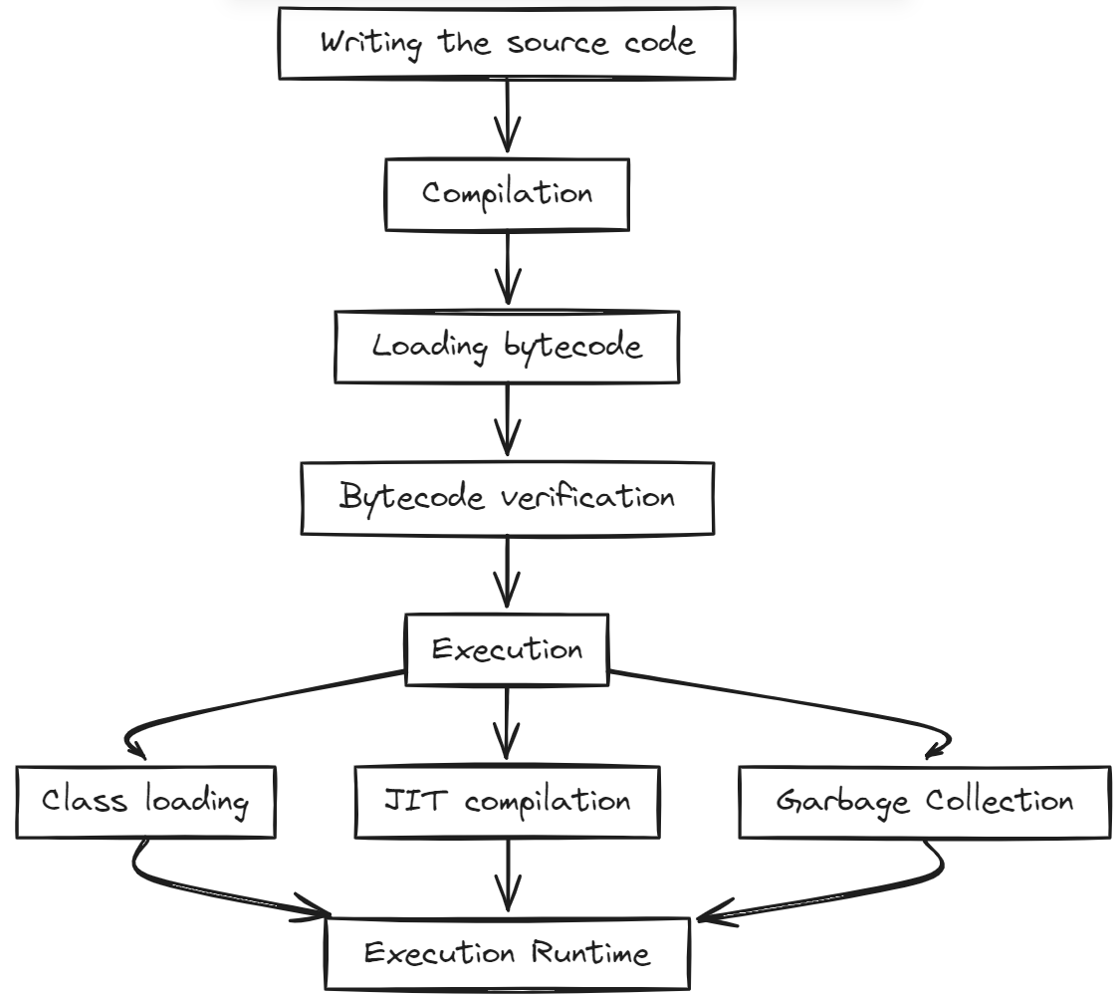

Java Compilation Process
- Writing the Code:
  - A programmer writes the Java code in a .java file.
  - This file contains source code written in the Java programming language.
- Compilation:
  - The Java source code is then compiled by the Java Compiler (javac).
  - The compiler checks the code for syntax errors and, if there are no errors, translates the Java source code into bytecode.
  - Bytecode is a set of instructions that looks like machine code but is not specific to any processor.
  - The bytecode is stored in a .class file.
- Loading the Bytecode:
  - The bytecode is loaded into the Java Virtual Machine (JVM) by the class loader.
  - The class loader loads the .class file into the JVM.
- Bytecode Verification:
  - Before the bytecode is executed, the JVM verifies it to ensure that it is valid and does not violate any security constraints. This is done by the bytecode verifier.
- Execution:
  - Finally, the JVM executes the bytecode. The JVM translates the bytecode into machine code that the underlying operating system can understand and execute.
  - This is done using the Just-In-Time (JIT) compiler, which converts bytecode into native machine code at runtime.

Steps in Detail:

1️⃣ Writing the Code

Create a Java source file HelloWorld.java:

public class HelloWorld {

public static void main(String[] args) {

System.out.println("Hello, World!");

}

}

2️⃣ Compilation

Command: javac HelloWorld.java

What happens:

The Java compiler (javac) compiles the source code (.java) into bytecode.

Bytecode is stored in a .class file: HelloWorld.class.

3️⃣ Loading the Bytecode

Command to run:

java HelloWorld

What happens:

The JVM starts.

The ClassLoader subsystem loads HelloWorld.class into memory.

Classes are loaded on demand, i.e., when first referenced.

4️⃣ Bytecode Verification

After loading, the JVM performs bytecode verification to ensure:

Type safety

Correct usage of instructions

No illegal memory access or security violations

Only verified bytecode is allowed to execute.

5️⃣ Execution

The JVM executes the main method:

System.out.println("Hello, World!");

Output on console:

Hello, World!

Execution happens via the interpreter or Just-In-Time (JIT) compiler, which converts bytecode to native machine code.

Summary of Flow

Write code → .java

Compile → .class (bytecode)

Start JVM → java HelloWorld

Load class → ClassLoader loads .class

Verify bytecode → JVM checks safety & correctness

Execute → main method runs

Example Code Explanation
Let's look at the example code in detail:
public class HelloWorld {
public static void main(String[] args) {
System.out.println("Hello, World!");
}
}

- public class HelloWorld { }: This defines a public class named HelloWorld. In Java, every application begins with a class definition.
- public static void main(String[] args) { }: This is the main method, which is the entry point for any Java application. The main method is always public, static, and void, and it takes a String array as an argument.
- System.out.println("Hello, World!");: This line prints "Hello, World!" to the console. System.out is a standard output stream, and println is a method that prints the argument passed to it, followed by a new line.

Summary
- Write Java Code: Create a .java file with your Java code.
- Compile Java Code: Use the javac compiler to translate the Java code into bytecode, resulting in a .class file.
- Load Bytecode: The JVM class loader loads the .class file.
- Verify Bytecode: The JVM verifies the bytecode for correctness and security.
- Execute Bytecode: The JVM executes the bytecode using the JIT compiler, translating it to machine code and running it on your computer.

Prepared by : Rishi Patel

